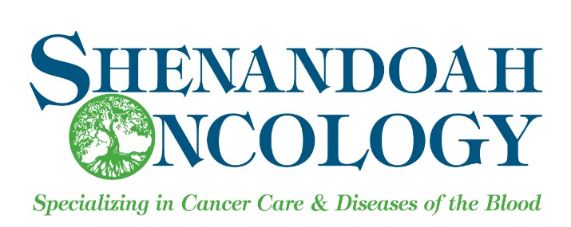
Acknowledgment of Receipt of Notice of Privacy Practices

Shenandoah Oncology, P.C. is committed to protecting your privacy and ensuring that your health information is used and disclosed appropriately. This notice of Privacy Practices identifies all potential uses and disclosures of your health information by our practice and outlines your rights with regard to your health information. Please sign the form below to acknowledge that you have received our Notice of Privacy Practices.

I acknowledge that I have received a copy of the Notice of Privacy Practices of Shenandoah Oncology, P.C.

Printed Name: _____________________________ DOB: ________________
Signature: _______________________________________________________
Name of Representative (if appropriate):
________________________________________________________________
Signature of Representative (if appropriate):
________________________________________________________________

Shenandoah Oncology, P.C. Use Only

Date acknowledgement received: _____________________________
OR
Reason acknowledgement was not obtained and employee signature:
___________________________________________________________________
___________________________________________________________________
Signature:___________________________________________________________

